**Step 1: Create a Free VM in Google Cloud**

1. **Log in to Google Cloud Console**
   * Go to https://console.cloud.google.com/ and sign in.
2. **Enable Compute Engine API**
   * In the navigation menu, go to **Compute Engine** > **VM instances**.
   * If prompted, enable the **Compute Engine API**.
3. **Create a new VM instance**
   * Click **Create Instance**.
   * Set the **Name** (jeeva-vm").
   * Select **Region**: Choose a region that offers a **free tier** (e.g., **us-east1, us-west1**).
   * Select **Machine Type**: Choose **"e2-micro"** (eligible for the free tier).
   * Boot disk: Select **Debian/Ubuntu** (or another Linux OS).
   * Firewall: Check **Allow HTTP and HTTPS traffic**.
4. **Create the VM**
   * Click **Create**, and the VM will start running.
   * Once created, note down the **External IP Address** (Public IP).

**Step 2: Ping the VM from Kali Linux**

1. **Open a terminal on Kali Linux**.

Run

Ping –c 4 <your-public-ip>

1. If the ping **does not work**, update firewall settings:
   * In Google Cloud Console, go to **VPC Network** > **Firewall**.
   * Create a new rule:
     + **Name:** allow-icmp
     + **Targets:** All instances
     + **Source IP:** 0.0.0.0/0
     + **Protocols and ports:** Check **ICMP**
2. Try pinging the VM again

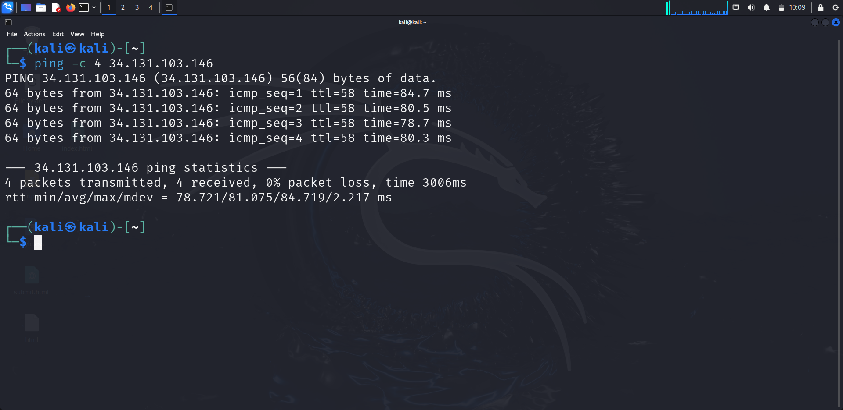

**Step 3: SSH into the VM and Check IP Information**

1. **Connect via SSH:**
   * ssh -i ~/.ssh/google_compute_engine jeea143evangeline@34.131.103.146
   * If you created the VM via Google Cloud Console, use the built-in SSH option.

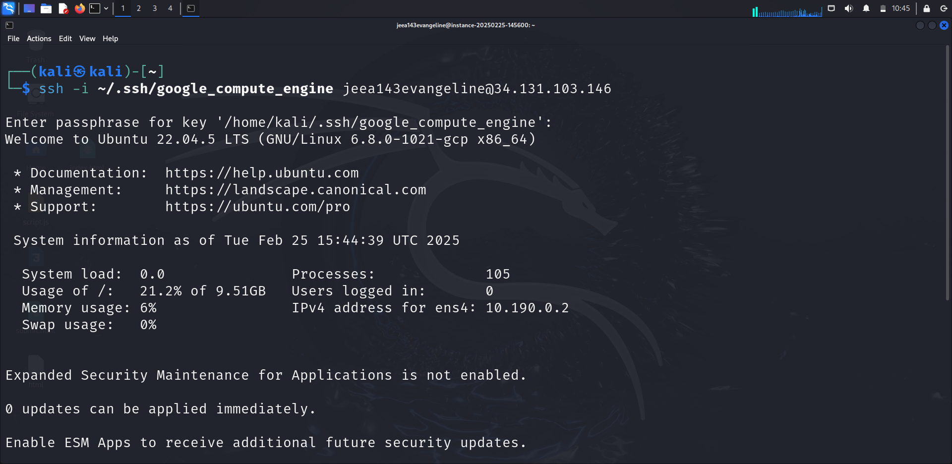

1. **Run the following command to check network interfaces:**

ip a

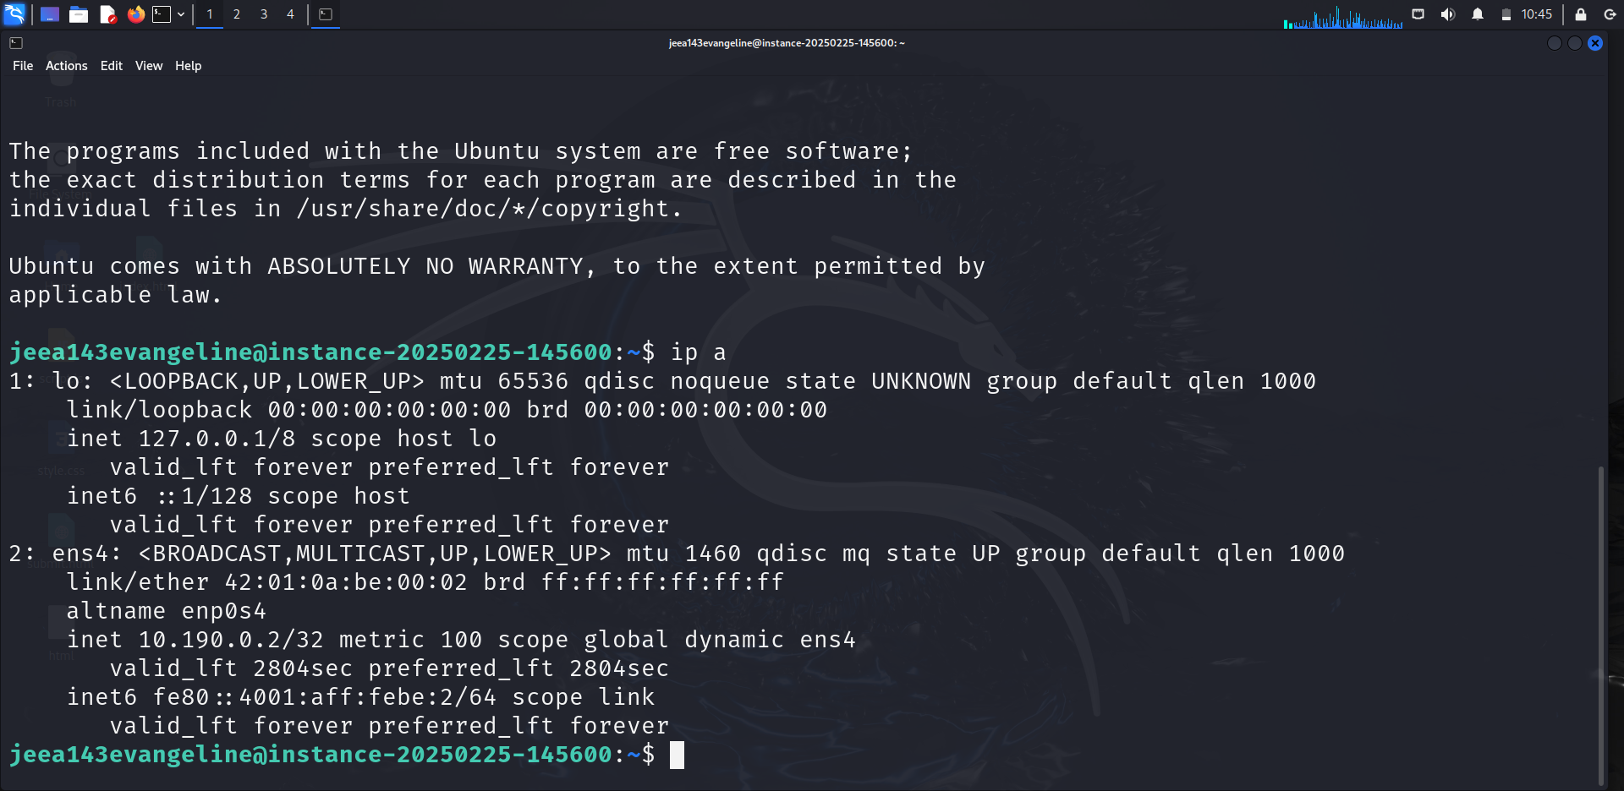

**Step 4: Ping the Public IP from the VM**

1. Find the **public IP** of your VM:

curl ifconfig.me

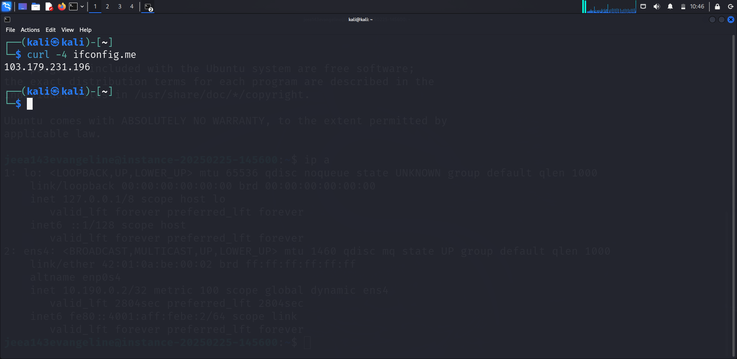

1. Try pinging the public IP from within the VM:

Ping

<VM_PUBLIC_IP>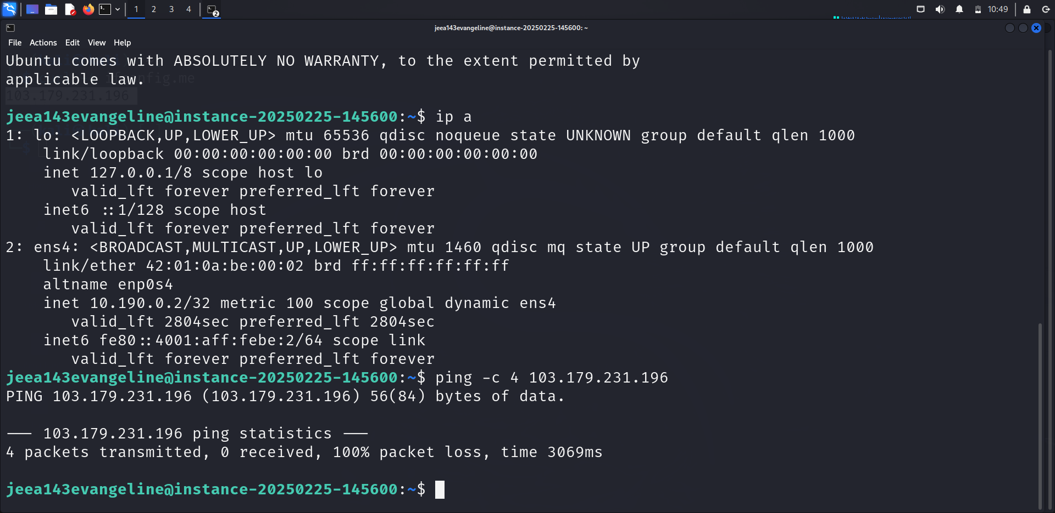

**Step 5: Explore and Shut Down the VM**

* Run:

sudo shutdown -h now

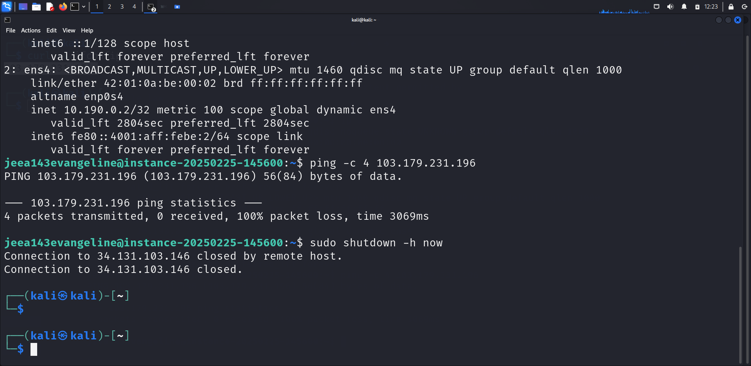

* Alternatively, stop the VM from the **Google Cloud Console** under **Compute Engine > VM instances**.

**Step 6: Terminate (Destroy) the VM**

* In Google Cloud Console, go to **Compute Engine > VM instances**.
* Select the VM and click **Delete**.